Technical Skillset Test

**Name:** Varun Raj C V **Email:** cvvarunraj@gmail.com  
  
  
Hello candidate. Thank you for showing interest in Change Healthcare and taking our technical skillset test.

# Instructions

1. Please complete **Test A and Test B**. Test C and D are optional, however if you do them there is a better chance of selection.
2. Completing this should take between 20 to 120 mins (depending on your skillset and experience)
3. You can write and test your code in your favourite IDE or online IDEs like <https://repl.it/>
4. For Tests B, C, and D, provide screenshots of **code** and **output** below each question.

It is a requirement to do these tests **independently without anyone’s help**. During the live interview you will be questioned to explain your code and outputs.

# Test A: Multiple Choice Test (Mandatory)

*Time Estimate: 10 mins*

* Please select the best answer. You are not expected to know the answers to all questions as they cover a lot of various technologies.
* Please do not guess. It is better to leave a question unanswered than to make an incorrect guess.
* Please highlight the correct answer using the background paint format ->

|  |  |  |  |  |  |  |  |
| --- | --- | --- | --- | --- | --- | --- | --- |
| Sample question: How to list the contents of a folder in Linux (Answer = C) | | | | | | | |
| A | whoami | B | sudo | C | ls | D | lsof |
| Q1. In Linux, the file permission -rwxr-x-r-x … | | | | | | | |
| A | Means the group has write permission | B | Means deletion is not allowed for the user | C | Can be set by command: chmod 755 | D | Can be set by command: chmod 766 |
| Q2. How many hosts (IPs) can be configured in CIDR range 192.168.1.0/16 | | | | | | | |
| A | 16 | B | 65534 | C | 254 | D | 65536 |
| Q3. [Which of the sets of statements below will add 1 to x if x is positive and subtract 1 from x if x is negative but leave x alone if x is 0?](https://www.proprofsdiscuss.com/q/1353521/which-sets-statements-below-will-positive-subtract-from-nega) | | | | | | | |
| A | If (x > 0) x++; else x--; | B | If (x > 0) x++; else if (x < 0) x--; | C | If (x == 0) x = 0; else x++; x--; | D | X-1==X+1 |
| Q4. In programming, recursion is best defined as: | | | | | | | |
| A | A for loop calling a method | B | An infinite loop | C | A while loop calling a for loop | D | A method calling itself |
| Q5. The command to stop a running docker container is: | | | | | | | |
| A | $ docker please stop | B | $ docker kill | C | $ docker stop | D | $ docker rm |
| Q6. Examples of popular cloud computing serverless technologies are: | | | | | | | |
| A | AWS Lambda or GCP Cloud function | B | AKS or GKE | C | Route 53 | D | F5 |
| Q7. Which is not an HTTP request method | | | | | | | |
| A | GET | B | POST | C | PATCHES | D | OPTIONS |
| Q8. Terraform can be best described as | | | | | | | |
| A | Territory formation strategies | B | An Infrastructure as code tool | C | Faster than docker | D | Perl’s replacement |
| Q9. The <a href=> tag is used to | | | | | | | |
| A | Make C++ pointers | B | Create an inline anchor | C | Make a header reference label | D | Create a hyperlink |
| 10. A key benefit of using cloud technology is | | | | | | | |
| A | Make us lazy | B | Ignore memory leaks | C | to scale horizontally with ease | D | Make it rain |

# Test B. Json Rest API (Mandatory).

*Time Estimate: 20 mins*

BoredApi.com is an online REST API that returns fun activities to do. E.g. <https://www.boredapi.com/api/activity?participants=2> will return an activity for 2 participants in json format.

Please do this exercise in python (or then in another popular programming language like C# or Java).

1. Requirement 1: In this coding exercise please create a method called “def get_activity (*num_participants*)” which when passed the number of participants (say 3), returns a string like this: For 3 participants, the activity we found is ‘Make a couch fort’
2. Requirement 2: If num_participants > 5 the API returns an error. The method “get_activity” should return the error like this: For 6 participants, an error occurred. Json: [{'error': 'No activity found with the specified parameters'}]
3. Requirement 3: Run this method in a for loop for 1 to 6 participants. The output should look like this:  
   For 1 participants, the activity we found is 'Do a jigsaw puzzle'  
   For 2 participants, the activity we found is 'Compliment someone'  
   For 3 participants, the activity we found is 'Go to a concert with local artists with some friends'  
   For 4 participants, the activity we found is 'Hold a video game tournament with some friends'  
   For 5 participants, the activity we found is 'Have a jam session with your friends'  
   For 6 participants, an error occurred. Json: [{'error': 'No activity found with the specified parameters'}]

Please find the code in: <https://github.com/cvvraj/chc_sre/blob/main/ex2/bored.py>

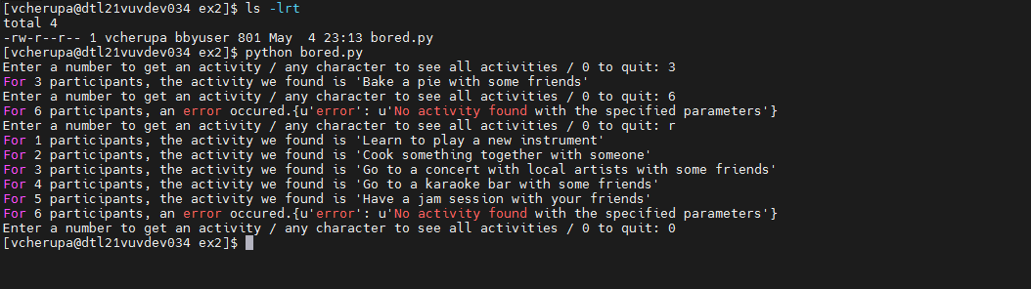

# Test C: Bash Regex Test (Optional)

*Time Estimate: 20m*

Given a bash variable is stored with sample log lines like this:

read -r -d '' SampleLog << EOM

192.168.1.33 - - [8/Jan/2021:14:10:18 +0600] "GET /pic/incrediblehulk.gif HTTP/1.1" 404 177 "-" "Mozilla/5.0"

192.168.1.43 - - [8/Jan/2021:14:11:18 +0600] "GET /pic/captainamerica.gif HTTP/1.1" 200 377 "-" "Chrome 3.0"

192.168.2.212 - - [8/Jan/2021:14:11:18 +0600] "GET /pic/batgirl.gif HTTP/1.1" 200 377 "-" "Internet Explorer"

192.168.1.101 - - [8/Jan/2021:14:11:18 +0600] "GET /pic/captainamerica.gif HTTP/1.1" 200 377 "-" "Mozilla/5.1"

192.168.1.33 - - [8/Jan/2021:14:11:18 +0600] "GET /pic/wonderwoman.gif HTTP/1.1" 500 377 "-" "Mozilla/4.0"

EOM

Write a bash script that using regex (e.g. AWK/SED/grep) outputs only the image requests as follows:

### > bash main.sh

### [incrediblehulk.gif]

### [captainamerica.gif]

### [batgirl.gif]

### [captainamerica.gif]

### [wonderwoman.gif]

Bonus: Change the script to also output the http return code as follows:

### > bash main.sh

### [incrediblehulk.gif] with code: [404]

### [captainamerica.gif] with code: [200]

### [batgirl.gif] with code: [200]

### [captainamerica.gif] with code: [200]

### [wonderwoman.gif] with code: [500]

<https://github.com/cvvraj/chc_sre/tree/main/ex3>

Please find the scripts in above github repo

main.sh uses awk to print the 7th and 9th columns in the file (similar to a log file) and uses sed in to remove /pic/

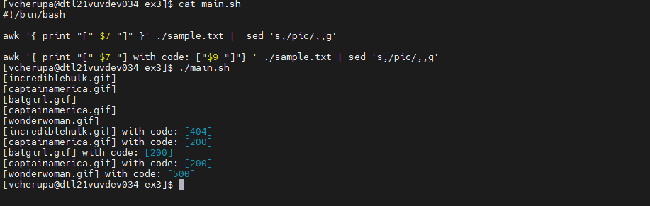

main2.sh works on the values in the variable SampleLog

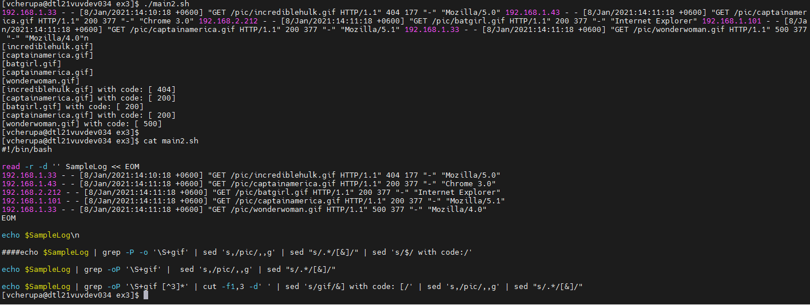

# Test D: Install Curl on a docker container (optional)

*Time Estimate: 30mins*

Please show us a script that would:

1. Launch/run an “alpine” docker container (https://hub.docker.com/_/alpine)
2. Install curl onto the container.
3. Save the container as a new image named alpine_curl.
4. Use docker run to execute the following command with the new alpine_curl image.
   1. curl <https://www.boredapi.com/api/activity?participants=2>

You can do this on any computer with docker installed or use free docker lab at <https://labs.play-with-docker.com/>  
Note: Once signed in and started a session, you can also Putty/SSH into the environment as opposed to using the browser UI.

Docker file and README.md in <https://github.com/cvvraj/chc_sre/tree/main/ex4>

